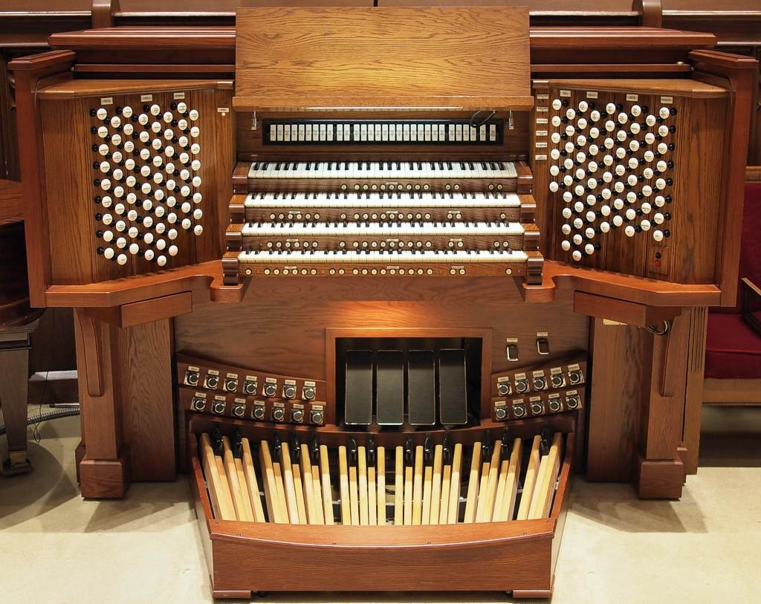
Organist Third Baptist Church

Third Baptist Church in St. Louis [MO] invites applications from organists to join its music ministry team. The successful candidate must demonstrate advanced organ proficiency and appreciation for sacred classical music; they should be able to lead the congregation in hymns, accompany the choir, and collaborate with the other music staff. Third Baptist Church is one of the most established in the city and is served by top class musicians and instruments. Sited in an elegant and large sanctuary, the magnificent 72-rank organ is of historic significance (Kilgen-Moller-Reuter), was completely restored in 2012, and may be heard on commercial recordings on the Regent label.

The paid post of Principal Organist is offered on a part-time basis, with considerable flexibility for scheduling. Liturgical and recital experience is preferred, and the successful candidate should possess a proven record for collegiality.

Those interested in this opportunity should submit their resume with a cover letter and provide references who can address how they might best work in this collaborative environment.
Applications should be sent to the Senior Pastor, Dr. Tommy Simons at <tsimons@third-baptist.org

Instrument
The organ at TBC is a fine instrument. It has been properly maintained, and it possesses a unique tonal quality and stops. Parts of it are historic, and it is quite versatile being adaptable for services, recitals and even accompaniment to silent movies shown on the screen overhead.
https://pipeorgandatabase.org/instruments/49790

Attendance Requirements
There is one service weekly on a Sunday, 11 am – 12:15 pm; this is preceded by a rehearsal with the choir 10:15 am. The second Sunday in September is a Youth Service, and the music staff do not participate. Thus, the total number of Sundays in a calendar year is 51.
[Music at the Good Friday service is provided by a string quartet, so the organist is not required.]

The weekly choir rehearsal is held on Wednesdays, 7:00 – 8:30 pm, at which the organist is required. These rehearsals do not occur in June, July and August. Since there is no Wednesday rehearsal following Christmas Day and Easter, the total number of Wednesday rehearsals in a calendar year is 37.

The Organist is entitled to 6 Sundays vacation per calendar year; on those occasions the church will pay for a substitute if one is required. Alternatively, the Organist Laureate, Brent Johnson, may be available to play.
After the allowed 6 Sundays, absences from either rehearsals or services may be possible upon agreement with the Pastor and Director of Music. At their discretion, the Organist must pay for a substitute.

Duties
As determined by the Director of Music, the Organist accompanies the choir, plays 2-3 hymns and 1-2 organ solos per service. The Organist suggests repertoire but the final decision rests with the Director of Music.

Recital series
The Organist is encouraged to plan and organize a series of organ recitals, 3 – 6 annually, that features the TBC instrument and performers from within the St. Louis area and beyond. An ideal period for this would be June, July and August, but this time period is open to negotiation with the Pastor and Director of Music. Initially, a budget of $1000 per recital would be available.

Remuneration and Benefits
Salary
The Organist is paid a salary twice-monthly via ACH bank deposit. Appropriate tax documents will be provided in a timely fashion each year.

Health and Retirement plans
These are not provided by the church.

Printed music
Third Baptist possesses a very small library of printed organ repertoire which the Organist may use. This is being gradually added to, for which a budget of $1000 per financial year is provided. Sheet music purchased in this way remain the property of the church.

Professional affiliations
The Organist is encouraged to subscribe or be affiliated to professional bodies like the American Guild of Organists and the Church Music Institute, and the church will reimburse such fees to a maximum of $500 per financial year.

Clothing
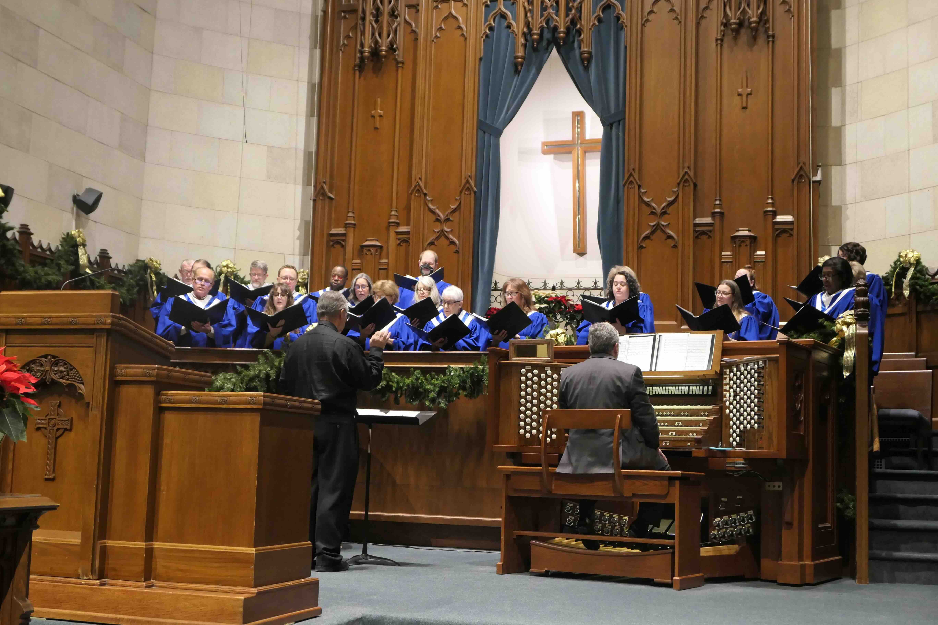
The Organist is required to attend services suitably dressed for worship, as determined by the Pastor. An organist’s robe is provided, and should be worn at least on festivals including Christmas Eve, Epiphany, Easter, Pentecost and Trinity Sunday. The Organist may be reimbursed for annual professional cleaning expenses for this robe.

